New modules and header options
The following are needs/ideas we would like to incorporate into new template assets.
- Every new header and module must be able to be incorporated seamlessly into our existing template systems.
- The images below are for directional purposes. We do not want our new modules to look identical. We welcome and want design ideas from those with better subject matter expertise.
- Other module/header suggestions are welcome before finalizing the scope of the CR.
New modules concepts:
- A module that illustrates in a simple fashion how to redeem points--
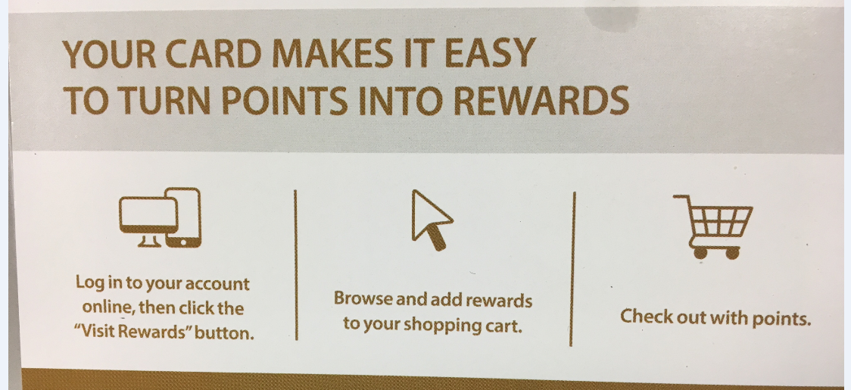
We like header text that introduces the point of the illustration below it—“It’s easy to turn your points into rewards”
The three steps above align with how ours would also read.
We need to be able to easily modify the text to customize the three steps for different clients/purposes

- An “Email security zone” that can be placed inside the footer, or be used as a standalone module (fine if requires two versions)—
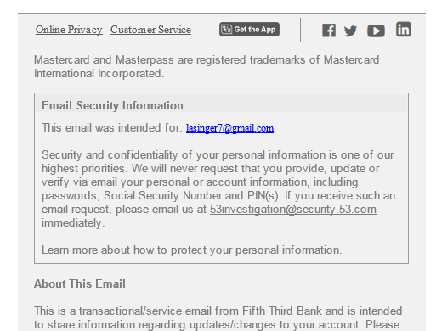
Another example—the content here is preferred to content above, but need flexibility:
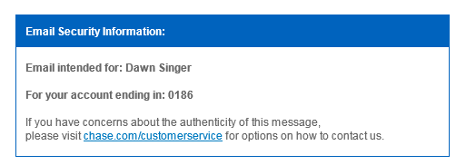

- A bulleted list, with color background and some sort of numbering. Unlike the example below, should have some sort of header

- Module for small images not in boxes, simple text beneath
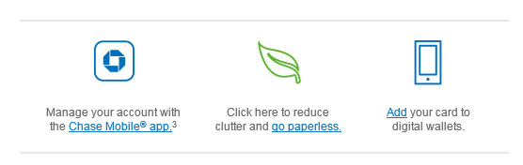
- A narrow, simple module like below with “flat” image and links—

- A module that explains how the Mastercard Pay with Rewards product works. (This will likely take some more effort to boil down but wanted to capture the idea to get started.)
High level idea for the module:
- Header call out: Use Pay with Rewards to pay for purchases at millions of locations worldwide
- Share the 3 (or 4) easy steps for how to use PWR
- Two versions – one version with app download links, one version without (not all Mastercard issuers utilize the PWR mobile app)

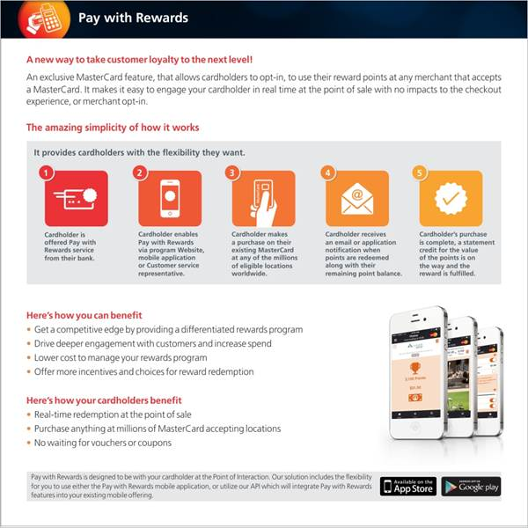
Another visual of Pay with Rewards:
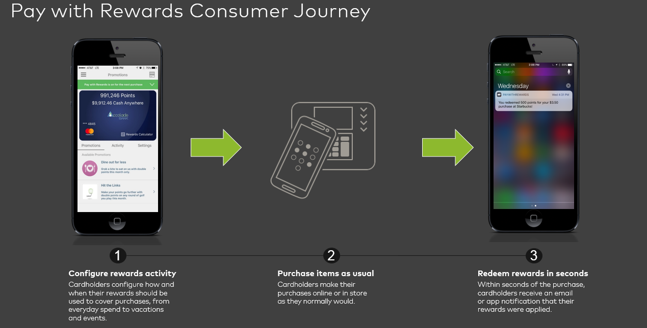
We would like to hear suggestions from Yesmail regarding other potential new modules. Of particular interest are ways to bring more color to our messages.
New Header Options:
- We want a minimalist header style, with a spot for the logo and virtually nothing else. Potentially fully rectangular preferable to the single rounded corner in this example, would like recommendation--

On the above, would like to have the ability to easily place the logo at the left, center or right.
- Another version of the header above to include a spot for quick links

- Logo and card image together in header—
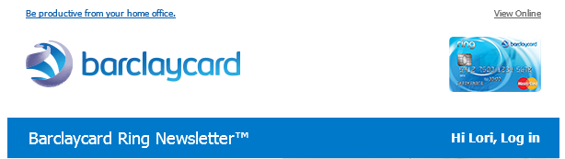

If Yesmail has any suggestions for another header option we would like to know.
We also like this way of blending the header into the rest of the email background. This might require more significant template changes though. Two examples:

