SL: Upcoming Changes to Marriott Bonvoy Benefits at The Cosmopolitan of Las Vegas

PH1: Discover Your Updated Benefits of Membership.  PH2: We Look Forward to Welcoming You Soon.
  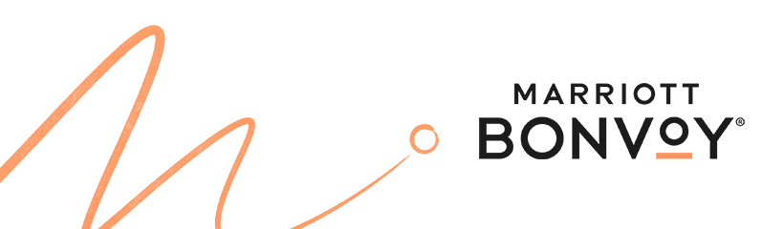
  » my account

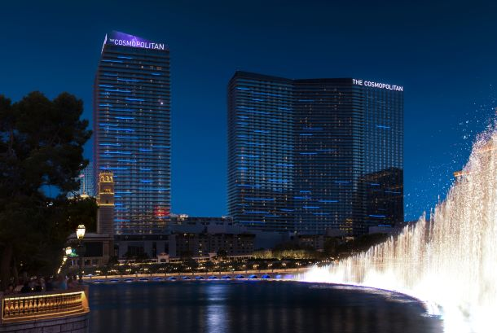

MGM Collection Brand Team - TCO133529241.jpg - All Documents (sharepoint.com)

Headline: Updated Benefits at The Cosmopolitan



Dear [FIRST NAME],
We wanted to share some important updates regarding your upcoming reservation at The Cosmopolitan of Las Vegas. Starting March 6, The Cosmopolitan will be a featured destination within our new strategic alliance with MGM Resorts. As such, the hotel will offer a set of unique benefits. We thank you for being a valued Marriott Bonvoy [ELITE TIER] member and look forward to delivering an incredible experience here and at any of our 10,000 locations worldwide.

<< SEE YOUR UPDATED BENEFITS >>

As a Marriott Bonvoy member, you’ll earn points on eligible spend, including room rate, in-room dining, and mini-bar purchases. We look forward to welcoming you to The Cosmopolitan and providing an enjoyable experience!

Web View

This is a Marriott International transactional email regarding your Marriott Bonvoy program membership. Even if you are opted out of Marriott Bonvoy marketing, you may still receive Marriott Bonvoy transactional emails on occasion regarding necessary updates or changes to the Marriott Bonvoy program. To manage your communication preferences, including unsubscribing from promotional emails, click here.
©2023 Marriott International, Inc.
You can also unsubscribe by writing to:
Marriott Bonvoy
910 West Legacy Center Way, Suite 100, Midvale, UT 84047 USA
You have received this email as a seed. To modify your preferences, log in to the Seed List Preference Center.

