Americas May Creative Outline
Kickoff: 3/27
IR: 4/3
DR1: 4/4

Hero: New + Renovated Hotels (New landing page)
Copy inspiration:
Next Stop: The Latest and Greatest; Check in, then check out our new and renovated hotels. Explore spaces designed for the traveler of today with our best rates.
Images: San Francisco - need to feature this market!

Secondary:
Resorts
Grand Getaways
LTS
Discover Local
New Resorts site - URL TBD, Addie to share content
Destination Spotlights - NYC, Palm Springs, Atlanta, Nashville and Houston

RABs:

Taylor Swift Sweepstakes
*Must use this image + verbiage verbatim
+ Must include Official Rules at bottom of email
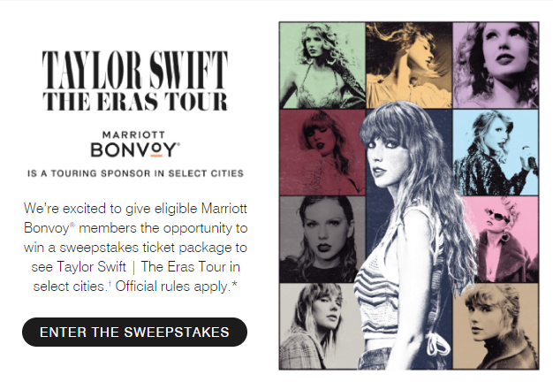

Boutiques Westin Sweepstakes
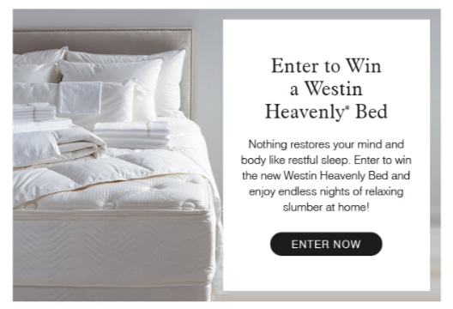
Image will likely change but verbiage included above (May MAU)

CALA MEO
The copy is very long so feel free to cut what you need.
They have an additional copy line for non-members, and a different URL - can we implement in our nonmember version?
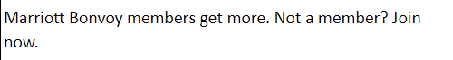
English
https://www.marriott.com/offers/get-10-000-bonus-points-at-all-inclusive-by-marriott-bonvoy-resorts-off-108827
https://www.marriott.com/offers/preview/OFF-108827-00
Get 10,000 bonus points at All-Inclusive by Marriott Bonvoy resorts
Your Ultimate Stay: 10,000 Bonus Points
Minimum of 4 nights stay required.
Amenities and outlets vary by property
Unlock paradise: 10K bonus points at All-Inclusive by Marriott Bonvoy resorts. Your dream escape awaits!
Escape to paradise and unlock an unforgettable Caribbean and Latin America adventure at a participating All-Inclusive by Marriott Bonvoy resorts! Book a minimum 4-night stay and be rewarded with 10,000 bonus points.
With this exclusive offer, every moment becomes a treasure, and every experience is enriched. Picture yourself basing in the sun on pristine beaches, exploring vibrant local culture, or simply relaxing in exquisite retreat. Whether you seek adventure, relaxation or a little of both, our all-inclusive paradise awaits. Book now and make memories that will last a lifetime!
Redeem your points for free nights, flights, unrivaled Marriott Bonvoy Moments™, and so much more.
Marriott Bonvoy members get more. Not a member? Join now.
Join Now URL: https://www.marriott.com/loyalty/createAccount/createAccountPage1.mi
Image options: attached in Teams channel - MEO IMAGES (1)

