Marriott Bonvoy, E2L December: MAR-1256
Creative Handoff to WP
November 20, 2023

Cover Page:

Message Tracker Link:
http://mtrack1.4at1.com/client/index.php?cc=mar&job=1256
Source Links:
http://preview.4at5.net/email_domains/mar/1256/mar_1256.html

Design Notes:

- PCIQ Subject Lines
- Short vs. Long (50/50 split)
- Member and Non-Member versioning
- Data Customization:
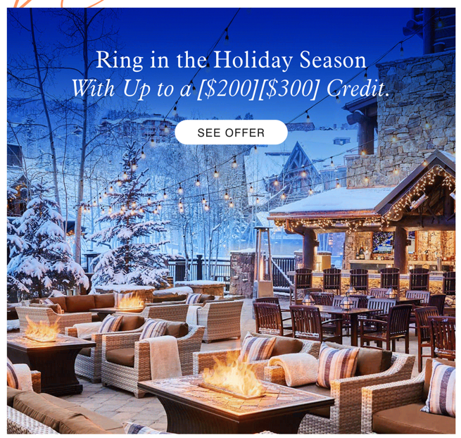

- Image Swap for the Hero <class="imgReplace1">
- Dynamic Module
