Member Account Box

Notes:

- Redesign of current account box to go into market with July’s MAU deployment.
- Design changes remove much of the messaging, which will be brought through in a separate Milestone message module.
- Alignment and font changes from the original.
- Different tracker bar images
- Assets included in folder: HTML, tracker bar images, mockup.

Mock-up of new design:

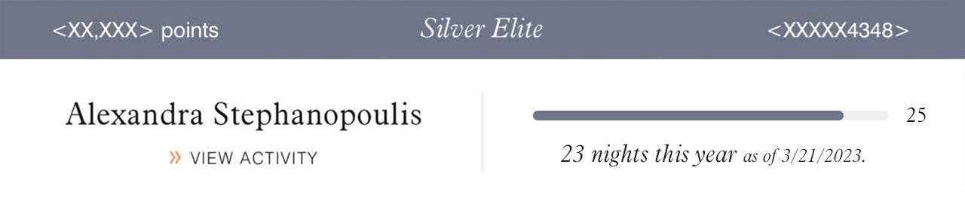

HTML:

- HTML includes all 6 tiered versions
- Data fields were leveraged from the current account box HTML for the fields kept in this design.
- For Titanimum & Ambassador levels, no bar graphic will show. Instead the nights stayed will be larger and set in Aldine Italic. The supporting copy below will be in Swiss Light for copy contrast.

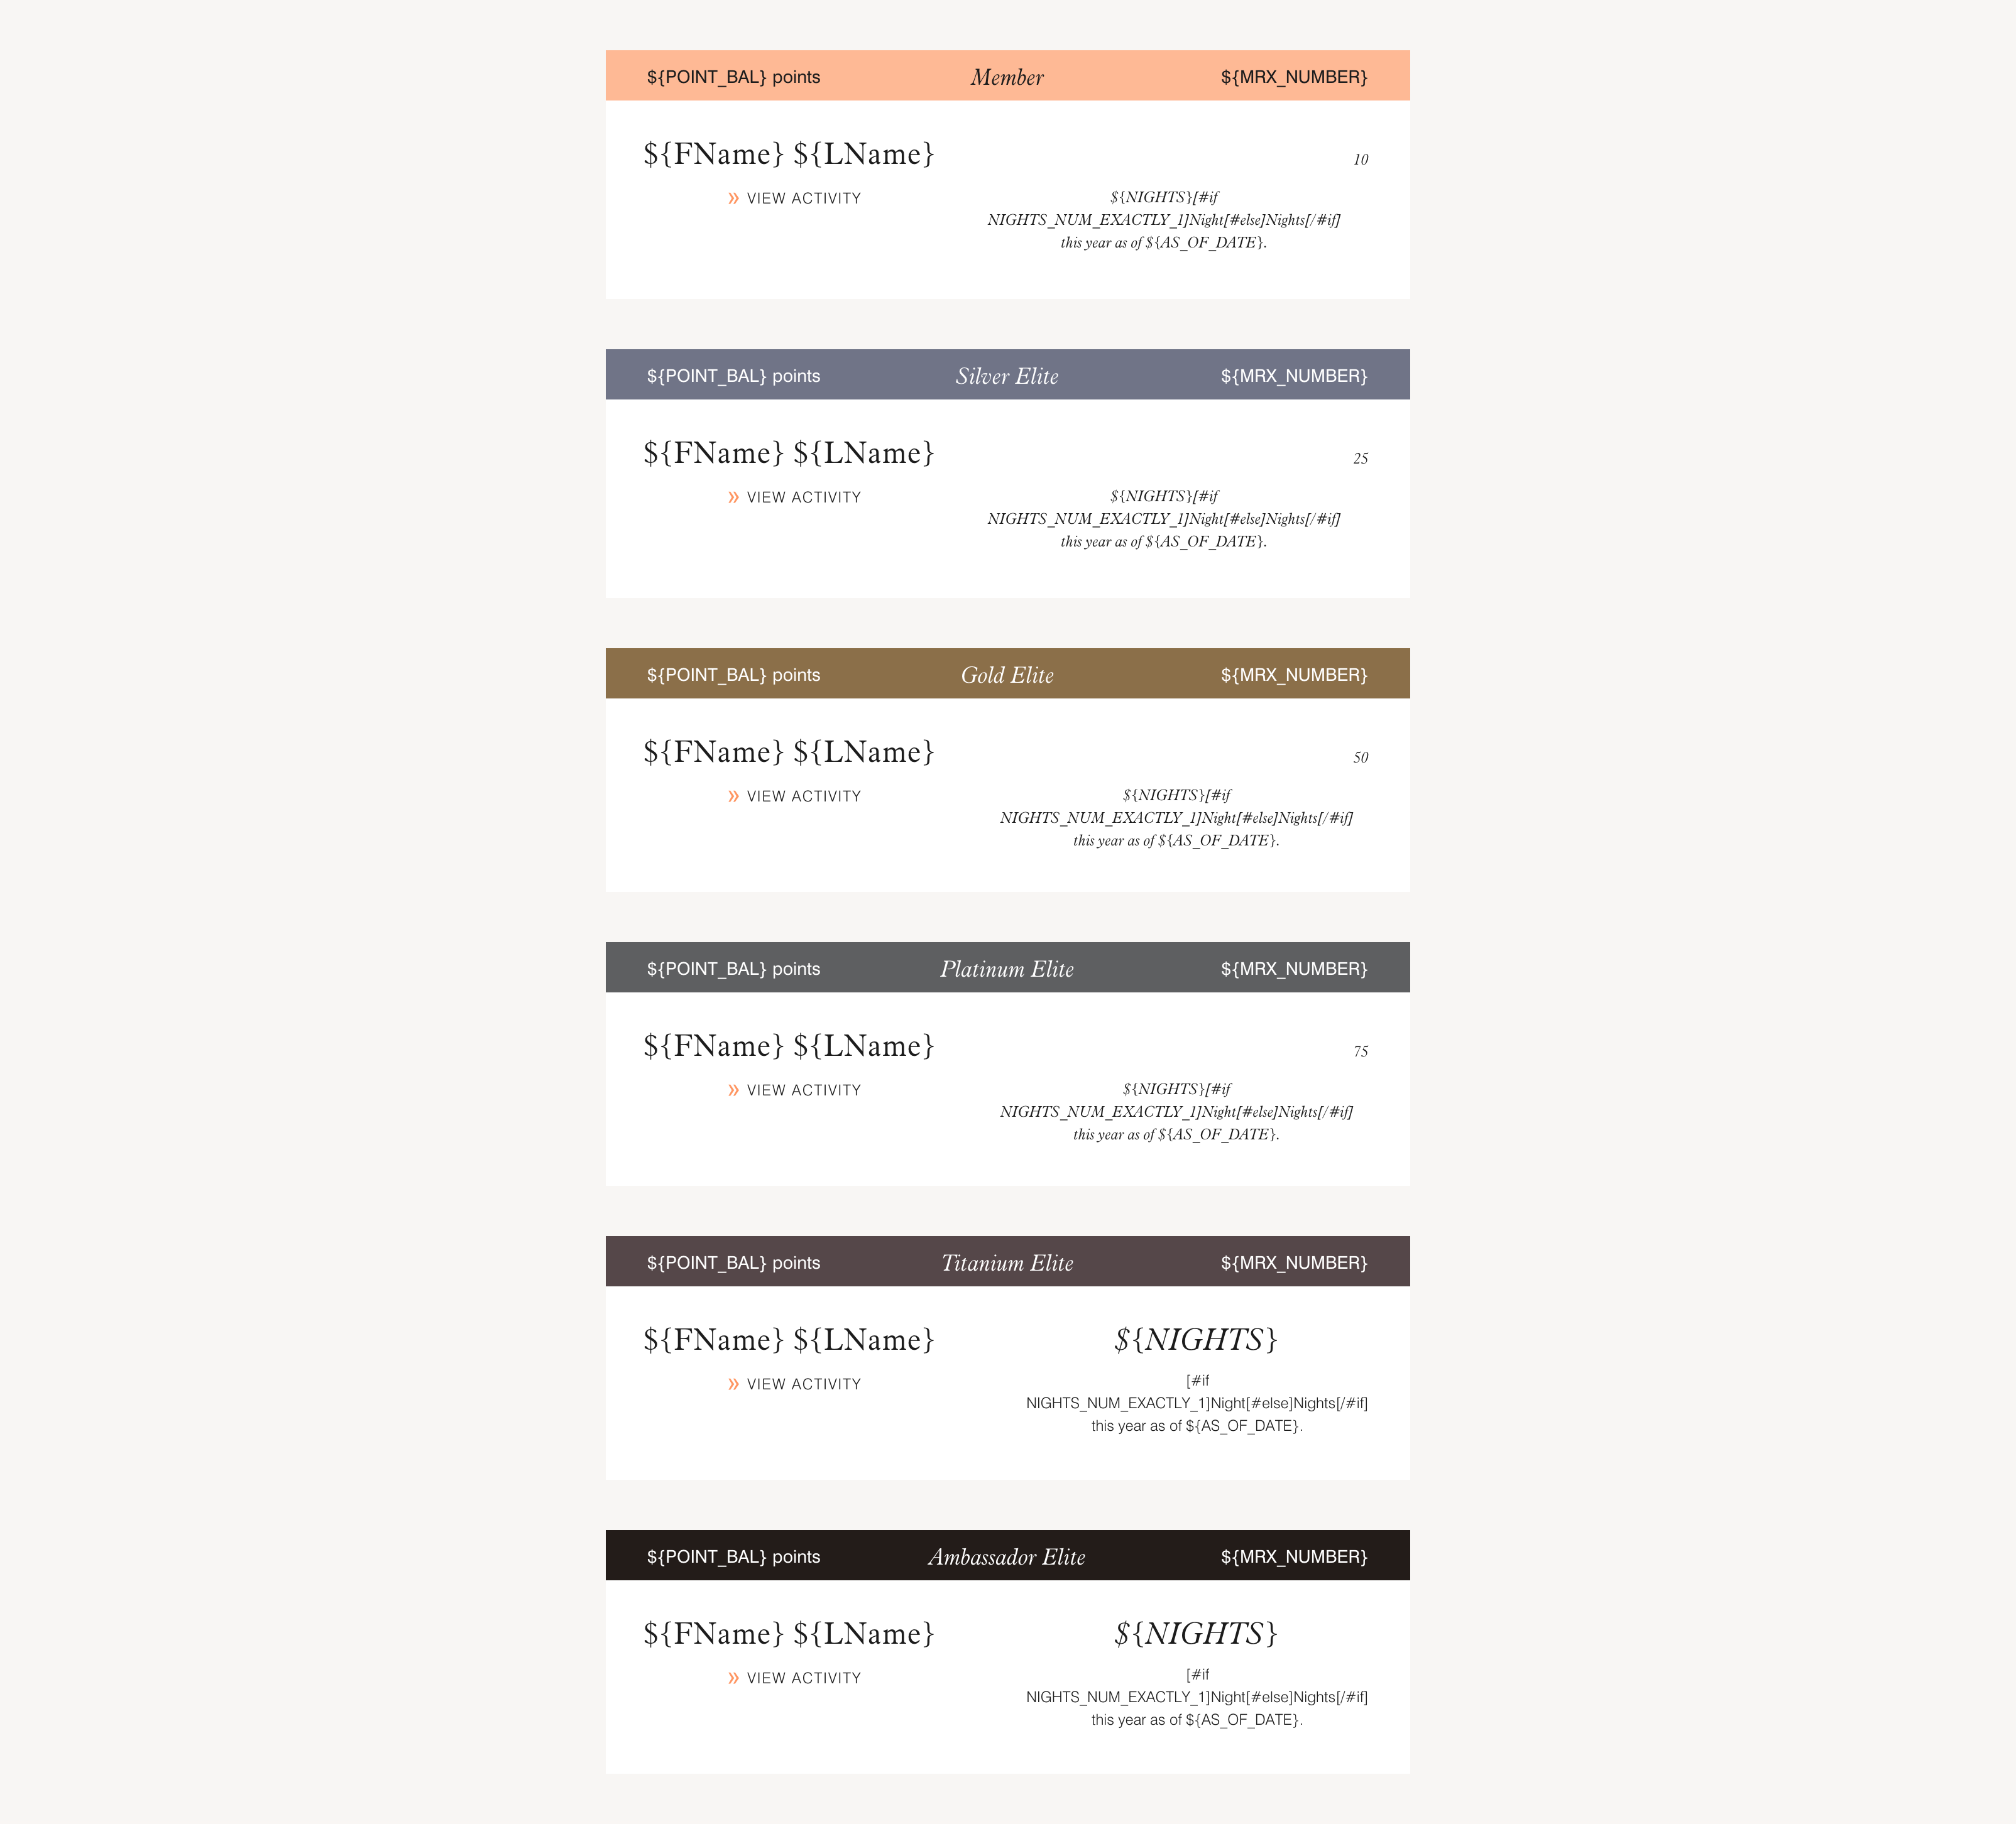

WP Help:

- For all versions (only Member shown below):
  - Ensure “FName LName” & “View Activity” CTA are centered with each other on the left side of box.
  - Please add a 4pxW by 105pxH vertical divider in color # f0f0f0, centered within the entire box to divide Member name and # of night info. (shown below in mockup)
  - Ensure the Nights info and # of nights (10,25,etc) more to the right so centered within the right half of the box.
  - Bar image should be horizontally centered with the Name and ending # of nights (as shown in mockup)

