MAU TRACKER BOX BUSINESS RULES ENG + INTL
There are 6 levels of account box and it is driven by DERIVED_LEVEL.
Member Tracker Box
DERIVED_LEVEL = B gets Member
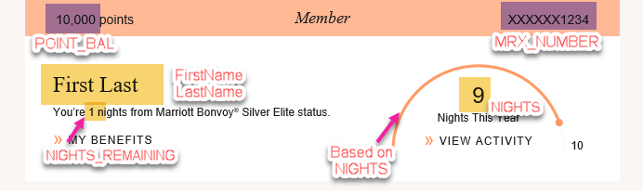
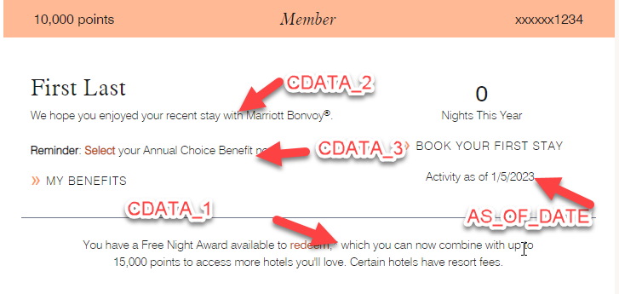

For all languages: Milestone Message under FirstName Last Name has two versions. Translation of milestones messages listed in a table at the end of this doc.
If CDATA_2 = NEWMBR, the following message will show up.

elseIf CDATA_2 = STAYER, the following message will show up.
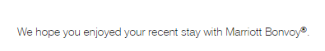
Else, the standard “You’re # nights from (next level).” will show up. (The plan from Marriott is to have more content for this milestone message area going forward, i.e. happy birthday, anniversary kind of message)

Second level of Milestone Message above My Benefits has two versions
If CDATA_3 = ACB, the following message will show up.
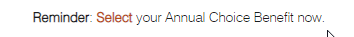
elseIf CDATA_3 = MFA, the following message will show up.
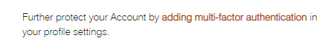
For ENG, there is a FNA message for profiles who does not have NFNA values in CDATA_1.
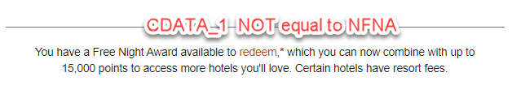
For ALL VERSIONS (besides Titanium & Ambassador), the right tracker image will show up for profiles who have more than 0 NIGHT. If not, the image won’t show and below message will show up.
The word “Night” show up for 1; “Nights” show up for 0 and more than 1.

ENG & BEN CHS
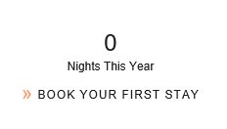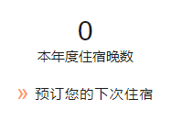
SPA JPN
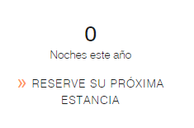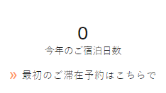
GER FRE
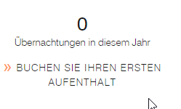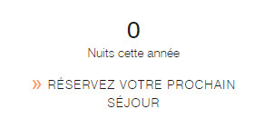
ITA POR
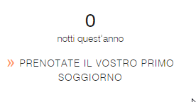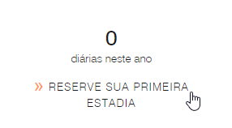
These are the tracker images for NIGHTS between 1 and 9.
NIGHTS=1 NIGHTS=2 NIGHTS=3 NIGHTS=4



NIGHTS=5 NIGHTS=6 NIGHTS=7 NIGHTS=8 NIGHTS=9


Screenshots for other languages Member tracker box:
POR
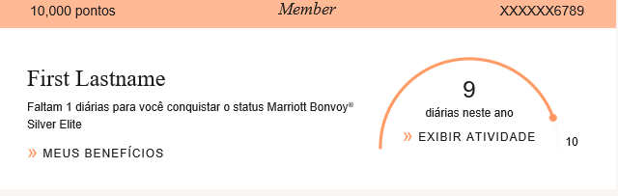
FRE
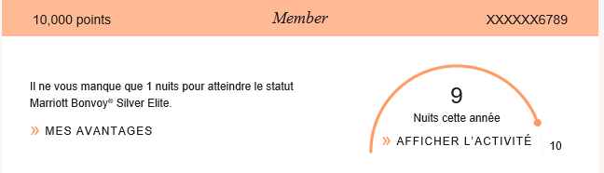

CHS
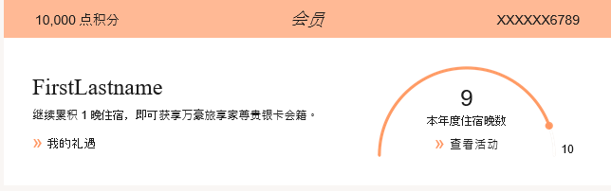
ITA
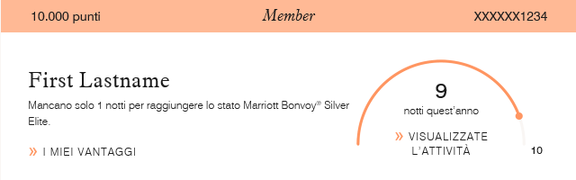
JPN
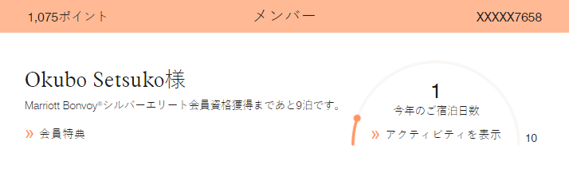
GER
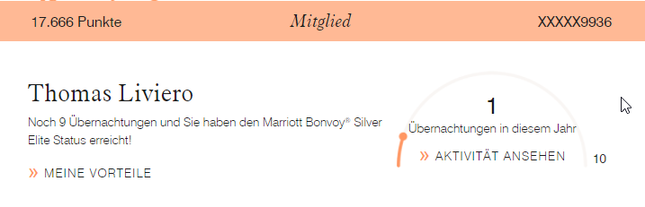
ITA
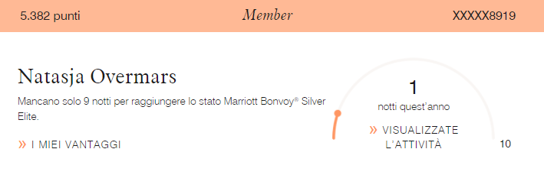
DERIVED_LEVEL = S gets SILVER
These are the tracker images for NIGHTS between 1 and 25.
NIGHTS between 21-25 NIGHTS between 16-20 NIGHTS between 11-15

NIGHTS between 6-10 NIGHTS between 1-5


Screenshots for Silver tracker box:
ENG/BEN
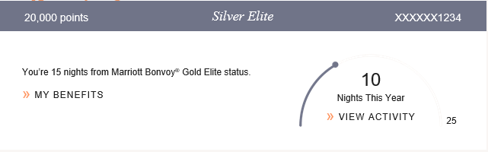
CHS
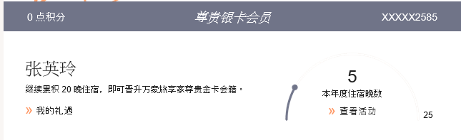
FRE
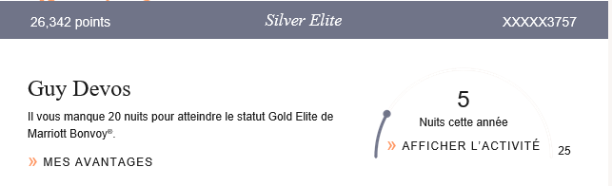
SPA
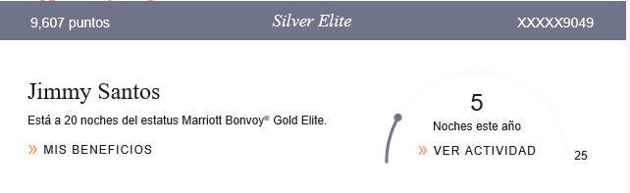

JPN
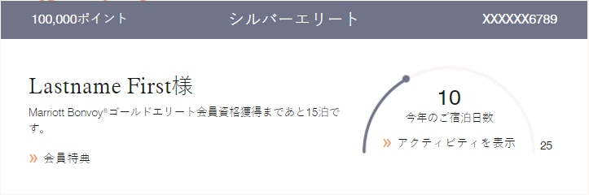
GER
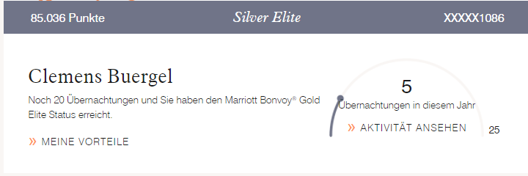
POR
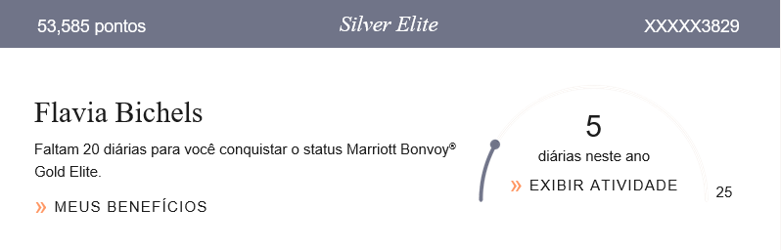
ITA
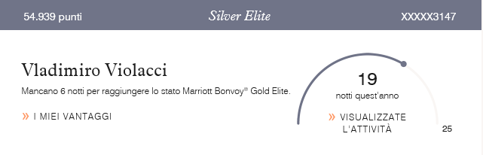
____________________________________________________________________________________
DERIVED_LEVEL = G gets GOLD
These are the tracker images for NIGHTS between 1 and 49.
NIGHTS between 46-49 NIGHTS between 41-45 NIGHTS between 36-40


NIGHTS between 31-35 NIGHTS between 26-30 NIGHTS between 21-25


NIGHTS between 16-20 NIGHTS between 11-15 NIGHTS between 6-10


NIGHTS between 1-5


Screenshots for Gold tracker box:
JPN
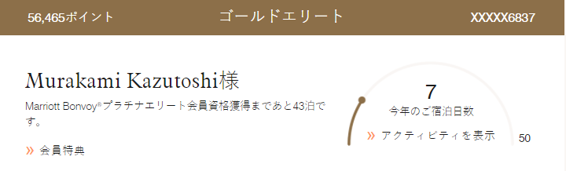
GER
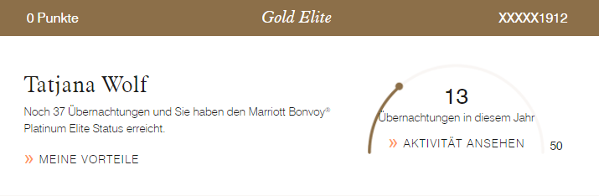
POR
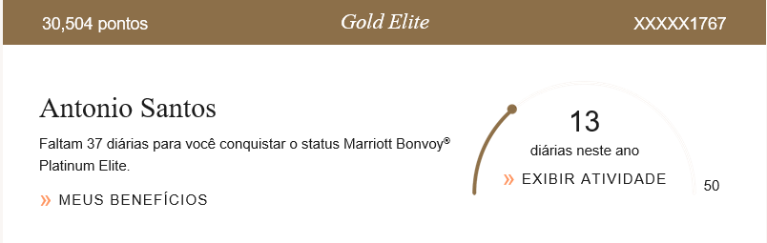
ITA
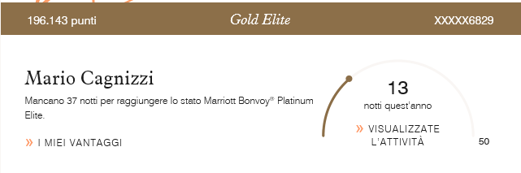
CHS
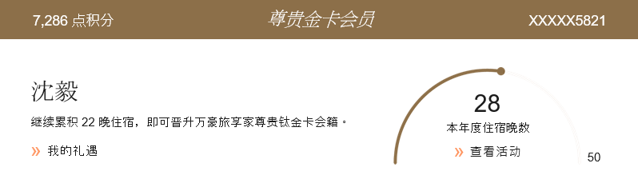
FRE
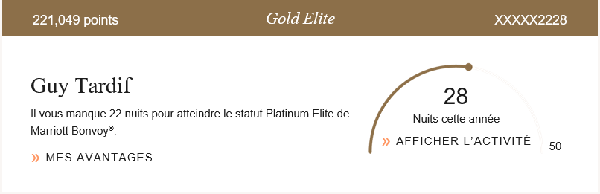
BEN
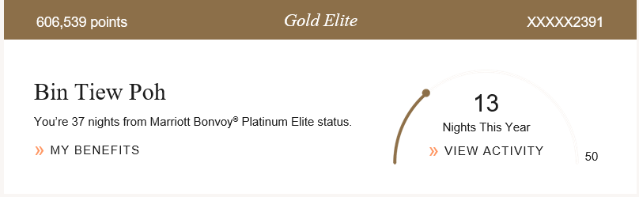
SPA
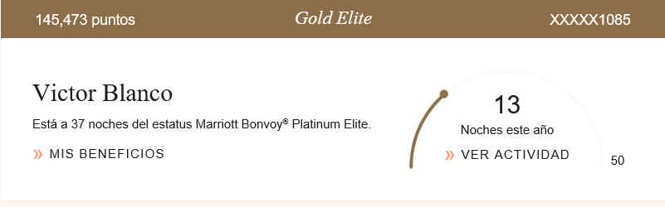
DERIVED_LEVEL = P gets PLATINUM
These are the tracker images for NIGHTS between 1 and 74.
NIGHTS between 68-74 NIGHTS between 61-67 NIGHTS between 53-60


NIGHTS between 46-52 NIGHTS between 38-45 NIGHTS between 31-37


NIGHTS between 23-30 NIGHTS between 16-22 NIGHTS between 8-15


NIGHTS between 1-7


Screenshots for Platinum tracker box:
JPN
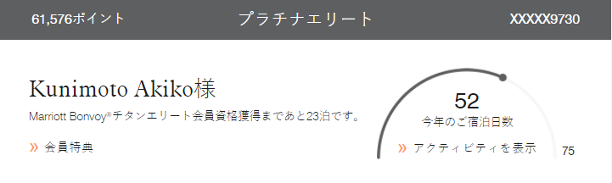
GER
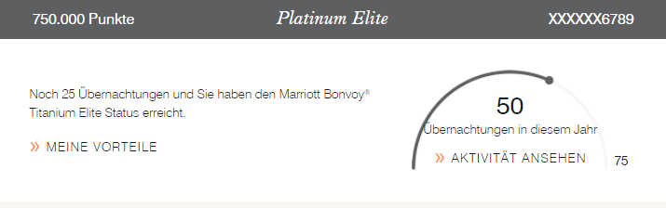
POR
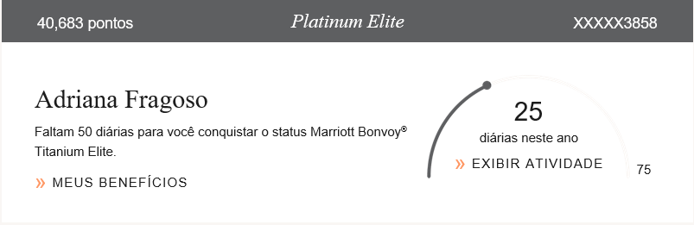
ITA
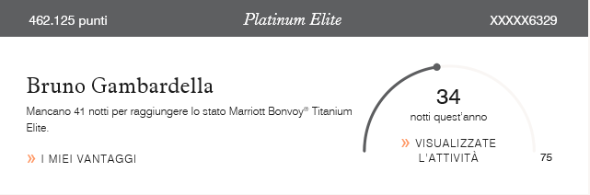
CHS
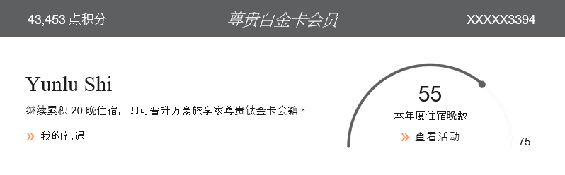
FRE
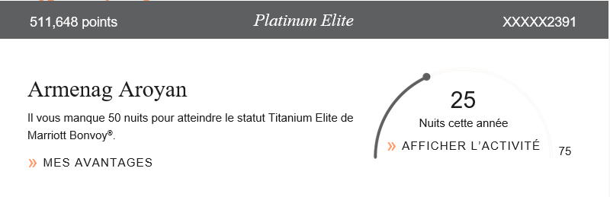
BEN
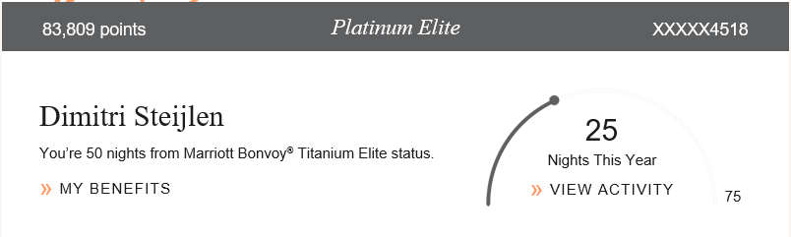
SPA
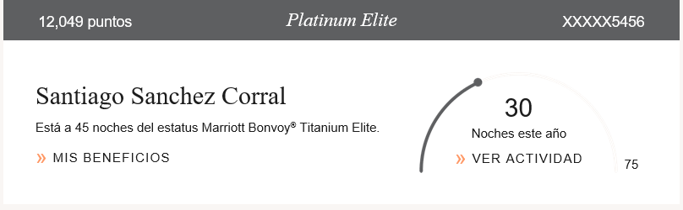
DERIVED_LEVEL = PP gets TITANIUM (turned off in 2021)
These are the tracker images for NIGHTS between 1 and 99.
NIGHTS between 91-99 NIGHTS between 61-70 NIGHTS between 51-60

NIGHTS between 41-50 NIGHTS between 31-40 NIGHTS between 21-30

NIGHTS between 11-20 NIGHTS between 1-10


Screenshots for Titanium tracker box:
JPN
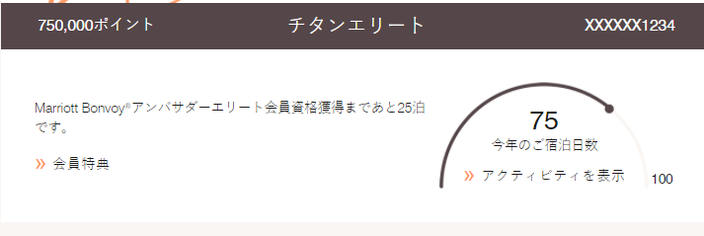
GER
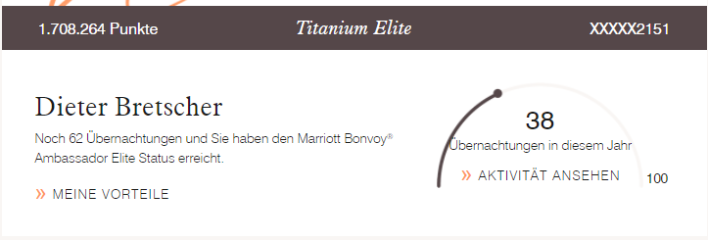POR
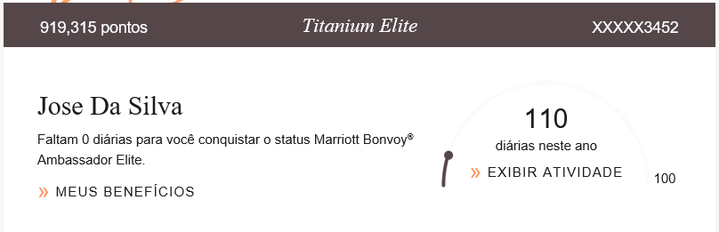
ITA
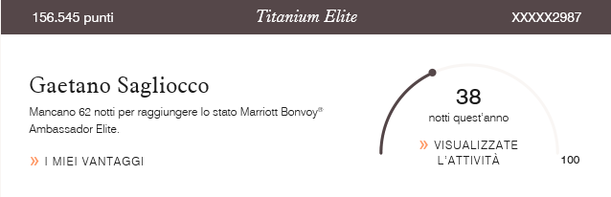
CHS
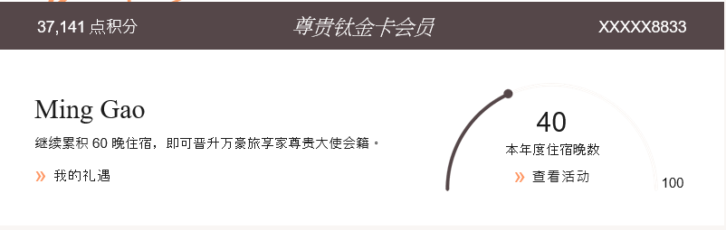
FRE
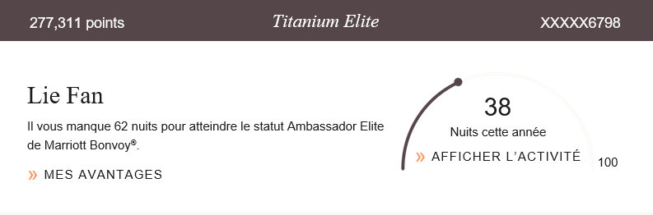
BEN
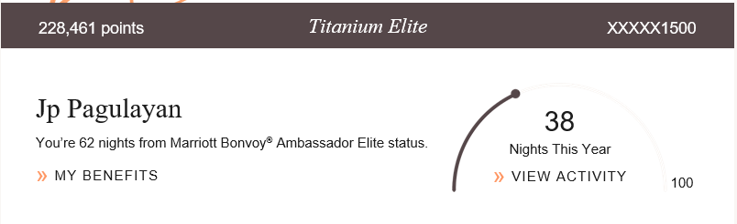
SPA
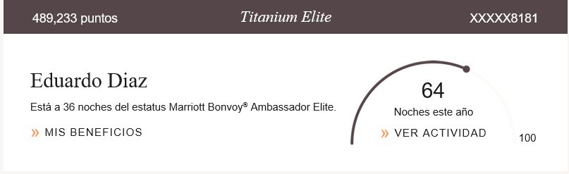
DERIVED_LEVEL = PA gets AMBASSADOR
JPN
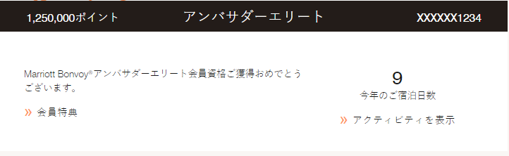GER
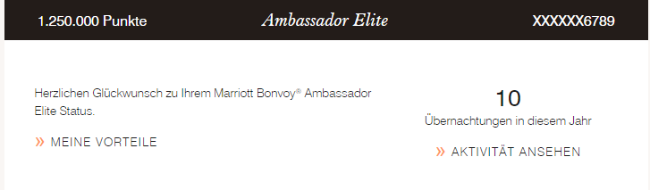
POR
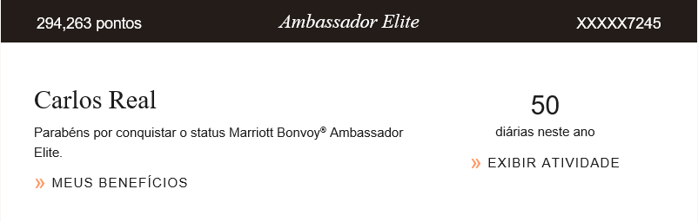
ITA
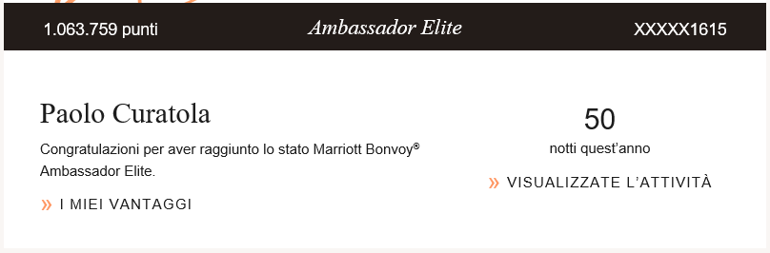
CHS
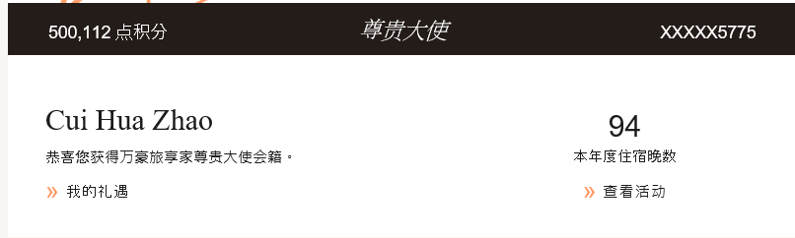
FRE
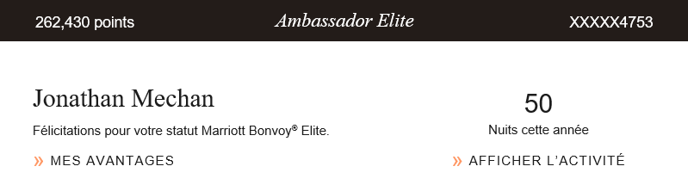
BEN
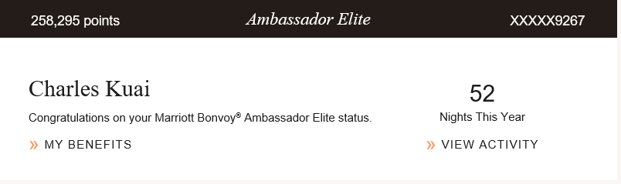
SPA

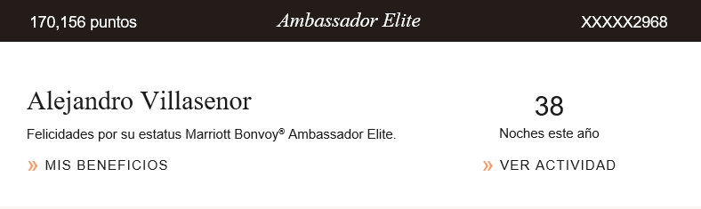
_____________________________________________________________________________________
Translation of all milestones messages:
Language | CDATA_2= NEWMBR | CDATA_2= STAYER | Default
ENG/BEN | Welcome to Marriott Bonvoy®(,FN). | We hope you enjoyed your recent stay with Marriott Bonvoy®. | You’re (0 nights) from Marriott Bonvoy® (Platinum Elite) status.
CHS | 欢迎加入万豪旅享家(,FN) 。 | 感谢您入住我们。 | 继续累计 (1)晚，即可获享万豪旅享家尊贵_(钛金)卡会籍。

Language | CDATA_3= ACB | CDATA_3 = MFA
ENG/BEN | Reminder: Select your Annual Choice Benefit now. | Further protect your Account by adding multi-factor authentication in your profile settings.
CHS | 欢迎加入万豪旅享家(,FN) 。 | 感谢您入住我们。

