Name of Brief:  Q2 GIFT CARD REACTIVATE PROMO |  |  | Submitter of this Brief: Kerry Greene  Submission Date: 1/18/2021
☐ New Project or  x Update to Existing Project - in market |  |  | Budget: 51 51974 4943  Accounting String: #790126
Accountable  Marketing Owner | Leigh Strickland
Approving  Senior Leadership Owner | Anne Smith
Other Stakeholders (RACI) | Responsible:  Danielle Dubrow | Accountable:  Leigh Strickland |  | Consulted:  Steve Maselko  Atina Gordon | Informed:  Brian Povinelli/ David Flueck

Objective – The What
Project Overview | Gift cards can be purchased now and redeemed later during a stay for hotel purchases, including rooms and room service, or at spas, restaurants and other outlets managed by the hotel. In order to support Q2 initiative to drive recovery, we are developing a limited time only 20% e-gift card discount offer to incent inactive members (points inactive in the past 12-24 months) to purchase a Marriott Bonvoy gift card for travel/spa/golf or other outlets in order to reengage.
Creative Ask | Develop highly targeted solo email to emailable audience who will be provided a dedicated code to redeem their 20% discount offer through Givex site. Based on the timing, can lean into the Q1 global promotion or seasonal feel (buy for you or your loved one) and enjoy later…  Update the look & feel of the site/e-gift card with new branding
Target Launch Date | April - June 2022  NOTE: All creative must delivered to channels on spec for each channel at least 4 weeks prior to anticipated launch date.
Target End Date | Pushing for April 2022
Milestone Dates | TBD based on kick-off but likely April/May

Purpose – The Why (for Marriott and for the Customer)
Consumer Operations Scorecard Objective | Which recovery objective from the Consumer Operations Scorecard does this support and why?  To drive inspiration for leisure travel booking and ancillary spend in 2022 for inactive members with high value offer.
Consumer Operations Scorecard Objective | x Drive Engagement  x Drive Topline Revenue |  | ☐ Experience our Hotels & Brands  ☐ Deepen Loyalty with Marriott
KPIs | Provide the top 1-2 Success Measures | Capture the baseline performance of each |  |  | Share the performance targets for each
KPIs | Primary KPI: e-Gift Card Sales Revenue  Secondary KPI: Inspire future travel  Incremental Stay Revenue | Increase in sales vs. previous year and previous month
Customer Outcome | Key take away is that the member should purchase an e-gift card during the limited-time, 20% discount offer period
Value to Customer | Targeted members will have exclusive access to limited time, 20% discount e-gift card offer that can be used when they are comfortable
Reasons to Believe | - Safe way to encourage travel when the member is ready  - Encourage re-engagement with the MBV program  - Can also be used on stay amenities such as golf, spa, etc,, making it a great gift option
Customer Journey | To which customer journey stage(s) does this project/message best align to meet its objective?
Customer Journey | X Imagine  ☐ Research + Commit  ☐ Get Ready |  |  | ☐ Experience + Enjoy  ☐ Return to Everyday Life
Differentiation | How does this communication differentiate us from the competition?  Prior to 2020, Marriott had not done marketing for the gift card since 2012. While competitors have been marketing to their members digitally and in brick in mortar stores. This level sets us with the competitor.

Audience – The Who
Target | Who are we trying to influence? Why? (3 sentences or less) Indicate primary in the boxes below; note if there are any secondary targets as well.  Influencing US 12-24 month stay inactive members through a highly targeted, 20% discount offer.
Target | X Members (Cardholders) |  | X Consumers (Non-Members/Non-Cardholders)
Target | X Members (Non-Cardholders) |  | ☐ B2B Customers
Regions | Where will this message be marketed?
Regions | X US/Canada  ☐ APEC  ☐ GCR | ☐ Middle East/Europe |  | ☐ CALA
Purpose-Driven Marketing | How are we addressing diversity & inclusion within our target audience?  With diverse images.

Deliverables – The How
Marriott Bonvoy & Portfolio Affiliation | How does this initiative pull through the portfolio platform and affiliate to Marriott Bonvoy?  E-gift cards can be used across the full breadth and depth of the brand portfolio (with exception of HVMI).
Deliverables & Specs | List any known deliverables and specs for this project.  Solo email  Sub-Page Banner :  Description: Main center image on All Subpage (like Gift Cards). This decorative and should not contain text or focal point  Image Size: 1700 x 150 pixel  Image Format: PNG or JPEG  E-gift Card Design:  Image Size: 415 x 240 pixel  Image Format: PNG or JPEG  File Name: Cardface_415x240.png (or. jpg)  Landing Page Copy:  Provide replacement copy under the header that would apply to this promo offer.  “Explore the possibilities of a Marriott eGiftCard. Choose from our gift card designs and treat yourself or someone else to a stay, spa day, culinary experience and more.”  As well as a caption for the eGift Card instead of “Company Promo Cards”.  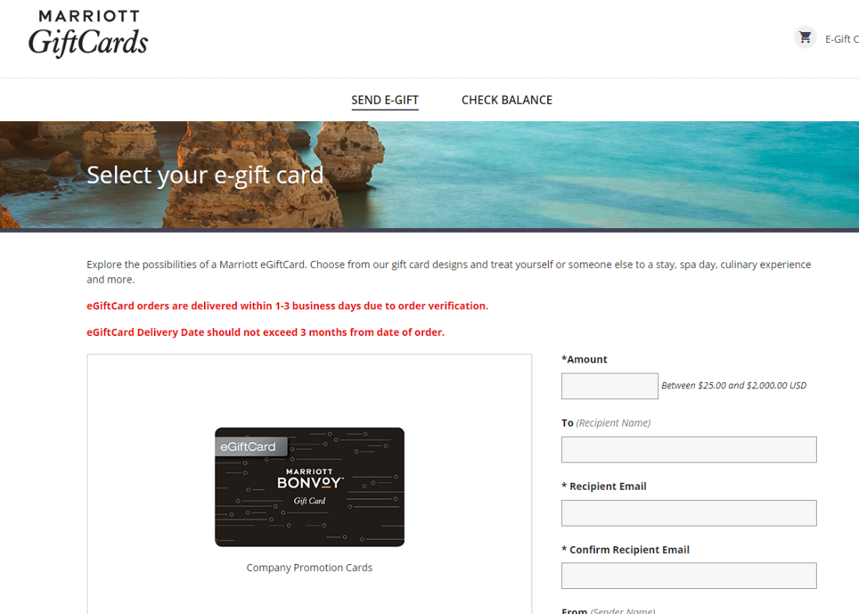
Requested Channel Support  (add link to specs doc)  Check all that apply: | Indicate if this is a priority message request for business and whether you’re aiming to secure high visibility placements.
 | X Email  ☐ Paid Media  ☐ Organic Social  ☐ MB Traveler  ☐ FlyerTalk/FlyerTea/Insiders  Community & Forums | ☐ M.com  ☐ App  ☐ Global Sites  X Dedicated Landing page  https://gifts.marriott.com/ | ☐ Internal Comms  ☐ PR  ☐ Print  ☐ Check here if open to agency channel recommendations
Translations | ☒ American English  ☐ Fr. Canadian  ☐ Chinese (email/mobile/app)  ☐ Japanese  ☐ South Korean | ☐ CALA Spanish  ☐ Portuguese  ☐ Arabic | ☐ Queen’s English  ☐ Italian  ☐ German | ☐ French  ☐ Spanish  ☐ Russian

Anything Else….
- Email should pull in the member’s 1-time code – email needs to clearly state this code is only good for 1 transaction and if a member decides to share their code before using it and someone else uses it, they will not be able to get the 20% discount code again for this offer
- To help sweeten the deal for these inactive members, we would like to feature the global promotion as part of the solo email (should timing align)
  - Hero should be about e-giftcard
  - Secondary message will be about registering for the global promotion and using the e-giftcard on a stay during the promo period to earn 1,000 bonus points and 1 Elite Night Credit per night of the stay.
  - If timing does NOT align, we would like a secondary message generating demand for summer travel
- Also look into incorporating Allianz Travel Insurance as a tertiary message – these members have been inactive for a while, so let’s help them rest assured that their full trip can now be covered
- Will update look & feel of e-gift card and promo hero to reflect new branding – leverage card art developed for Owner Kits as inspiration of how to pull through new branding
Current e-Giftcard Art
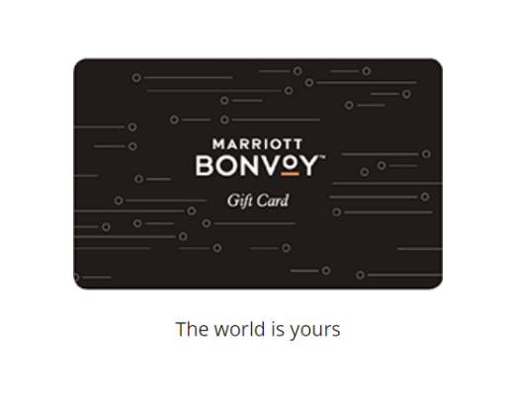
New Owner Card Art (For Reference)
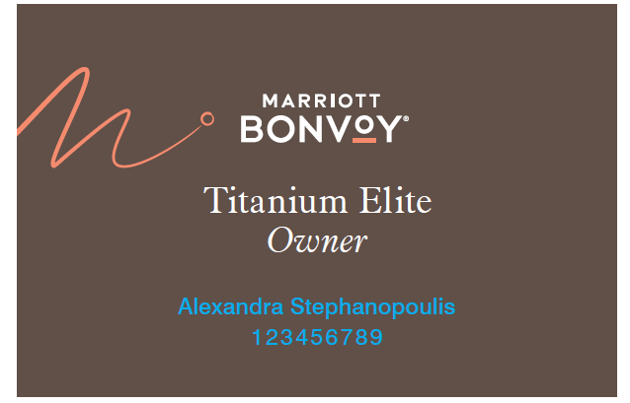
- Maybe we do a test (1 to 5 million rather than the full 11 million US inactives) to gauge performance and then roll out to balance if successful.
- Current emailable inactive US population:
 | US Emailable Pop
US members - stay inactive in last 24 months | 4,887,411
US members - stay inactive in last 12 months | 6,549,579

- Exclusions to Implement in Email Data File:
  - WE NEED TO EXCLUDE FLORIDA RESIDENTS as there may be unintended use (applied to golf club membership) – we want people staying in our hotels.
  - WE NEED TO EXCLUDE MEMBERS WHO HAVE RESERVATIONS ON THE BOOKS
  - WE NEED TO EXCLUDE MARRIOTT ASSOCIATES

Desired / Anticipated Project Plan
Stage |  | Date | Decision Maker(s)
1 | Submit Project / Creative Brief
2 | Brief Prioritized in Message/Channel Alignment Forum
3 | Conduct Message Kick-Off Meeting (include Channels, Creative, Analytics Resources)
4 | Finalize Content and Creative Assets
5 | Pre-view Customer Journey Experience
6 | Launch
7 | Post Launch Performance Review

