September eNews
mar_0550 HANDOFF

Cover page:

http://preview.4at5.net/email_domains/mar/0550/mar_0550.html

1 version

- People will receive either the MegaBonus hero + Travel Deals secondary article, or just the Travel Deals hero. Not both.

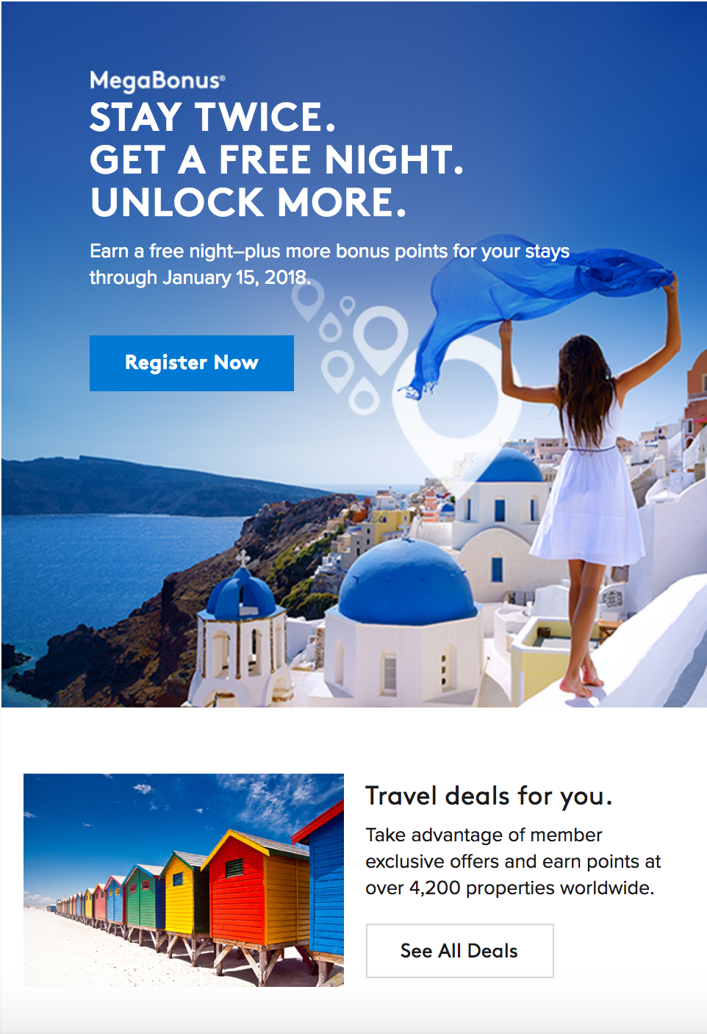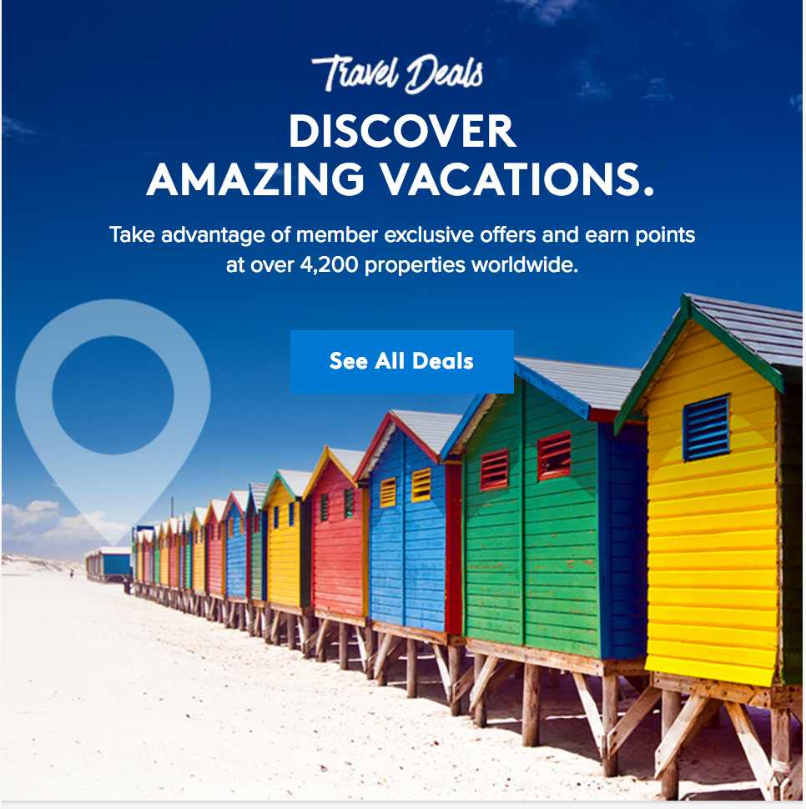

- The 4 article-style modules under “Travel, Transformed” are placeholder. They will dynamically populate from the MVP page

- Facebook Messenger image will link to a video, and the image will be created by Wylei. What’s currently in layout is just a placeholder.

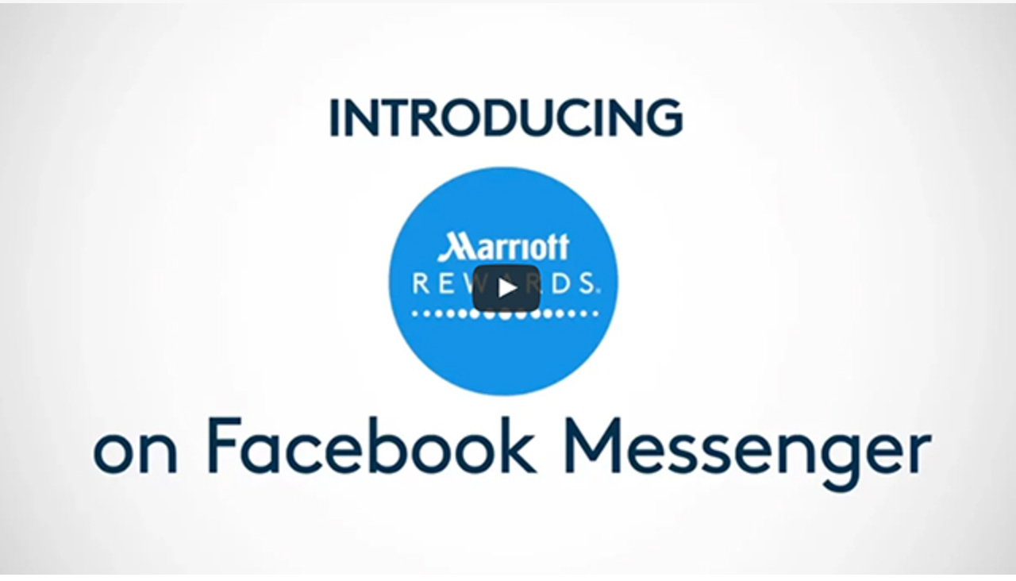
- Name personalization for Facebook Messenger module

- “Plan your next trip to the mile high city” module and 3-across below it will be dynamically populated
  - Also, please double-check that registration marks match what is in layout across all possible hotels

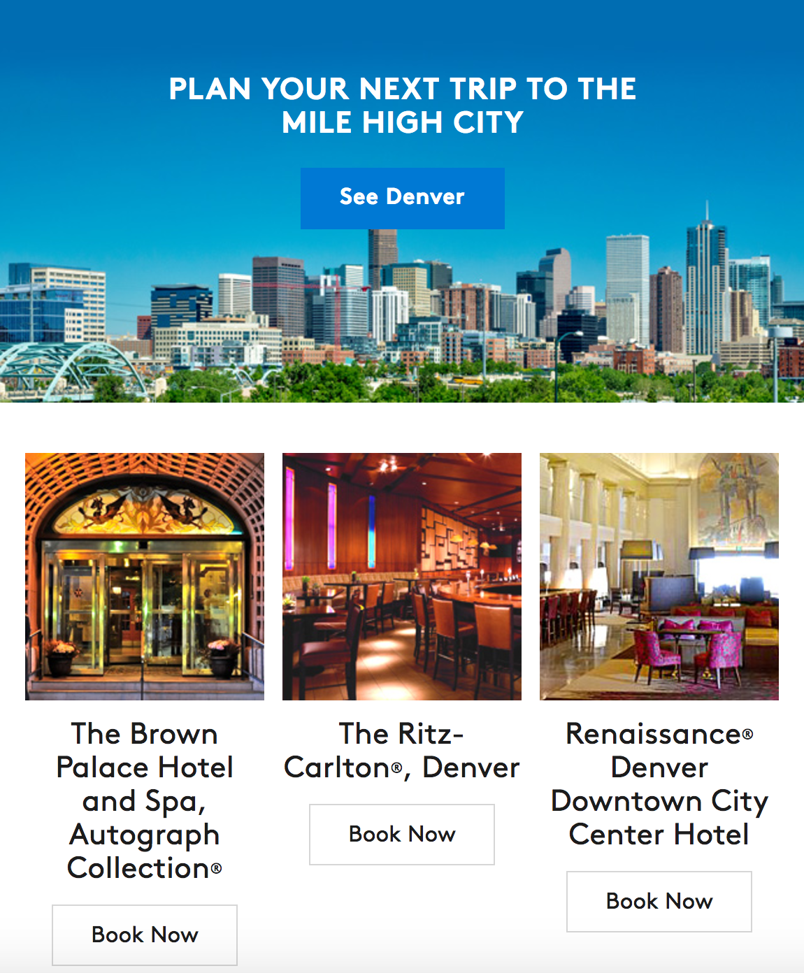

- “D.C., Chicago, Los Angeles, Atlanta” module is made up of individual images that will be dynamically populated by Wylei
  - Please note: I updated the style tag for each of those images to remove the background color (style=”display:block” instead of style=”display:block; background-color:939393;”

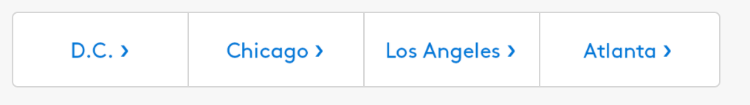

- Coded “See all new hotels > CTA within the F5 module, will probably need to be cleaned up

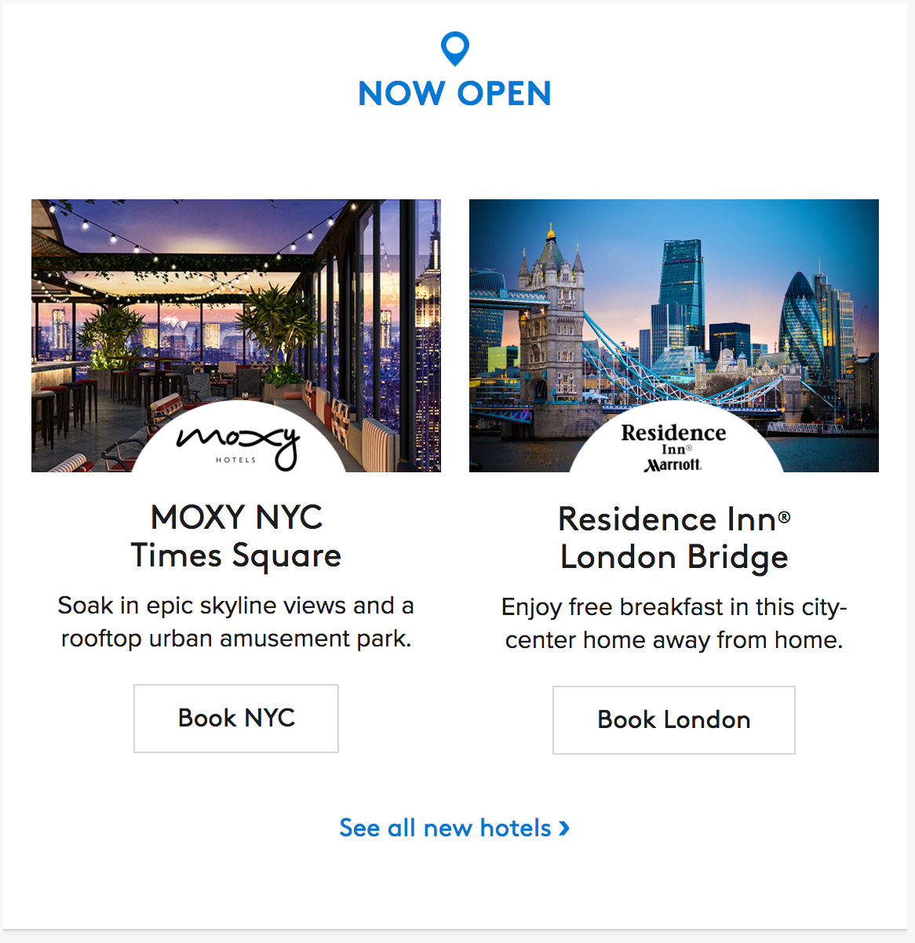

MVP Specific Notes:

- MVP offers that are new or revised from last month can be seen under “New/Revised MVP Offers”

- For all of the modules with logo next to the CTA, I updated the style tag for each of those images to remove the background color (style=”display:block” instead of style=”display:block; background-color:939393;”. That is why they’re appearing in the New/Revised MVP Offers page even though no copy/photo edits were made.

- The following existing MVP modules had a headline change (removing the period), but because the change is so small, we’re requesting Lisa make the update directly with Epsilon.

  - Marrott Rewards Moments
  - Exclusive travel deals
  - The Ritz-Carlton Club Level
  - Free Breakfast offer

