0481 Summer MegaBonus Registration Confirmation
WP Handoff Doc – Template 2.0 Version

Cover Page:
http://preview.4at5.net/email_domains/mar/0481/mar_0481.html

Design:
http://preview.4at5.net/email_domains/mar/0481/Design_2.0_v1.html

Background

- This email was also designed in template v14 in Spring 2017. The v14 version was coded by WP in April, and launched in May 2017.

- A 2.0 design was requested by the client for sends going out in summer 2017. This is the 2.0 version we are discussing here. Once coded, this will replace the v14 version being sent out.

- Even though we translated the v14 version to Spanish and Chinese, we will not be translating the 2.0 version.

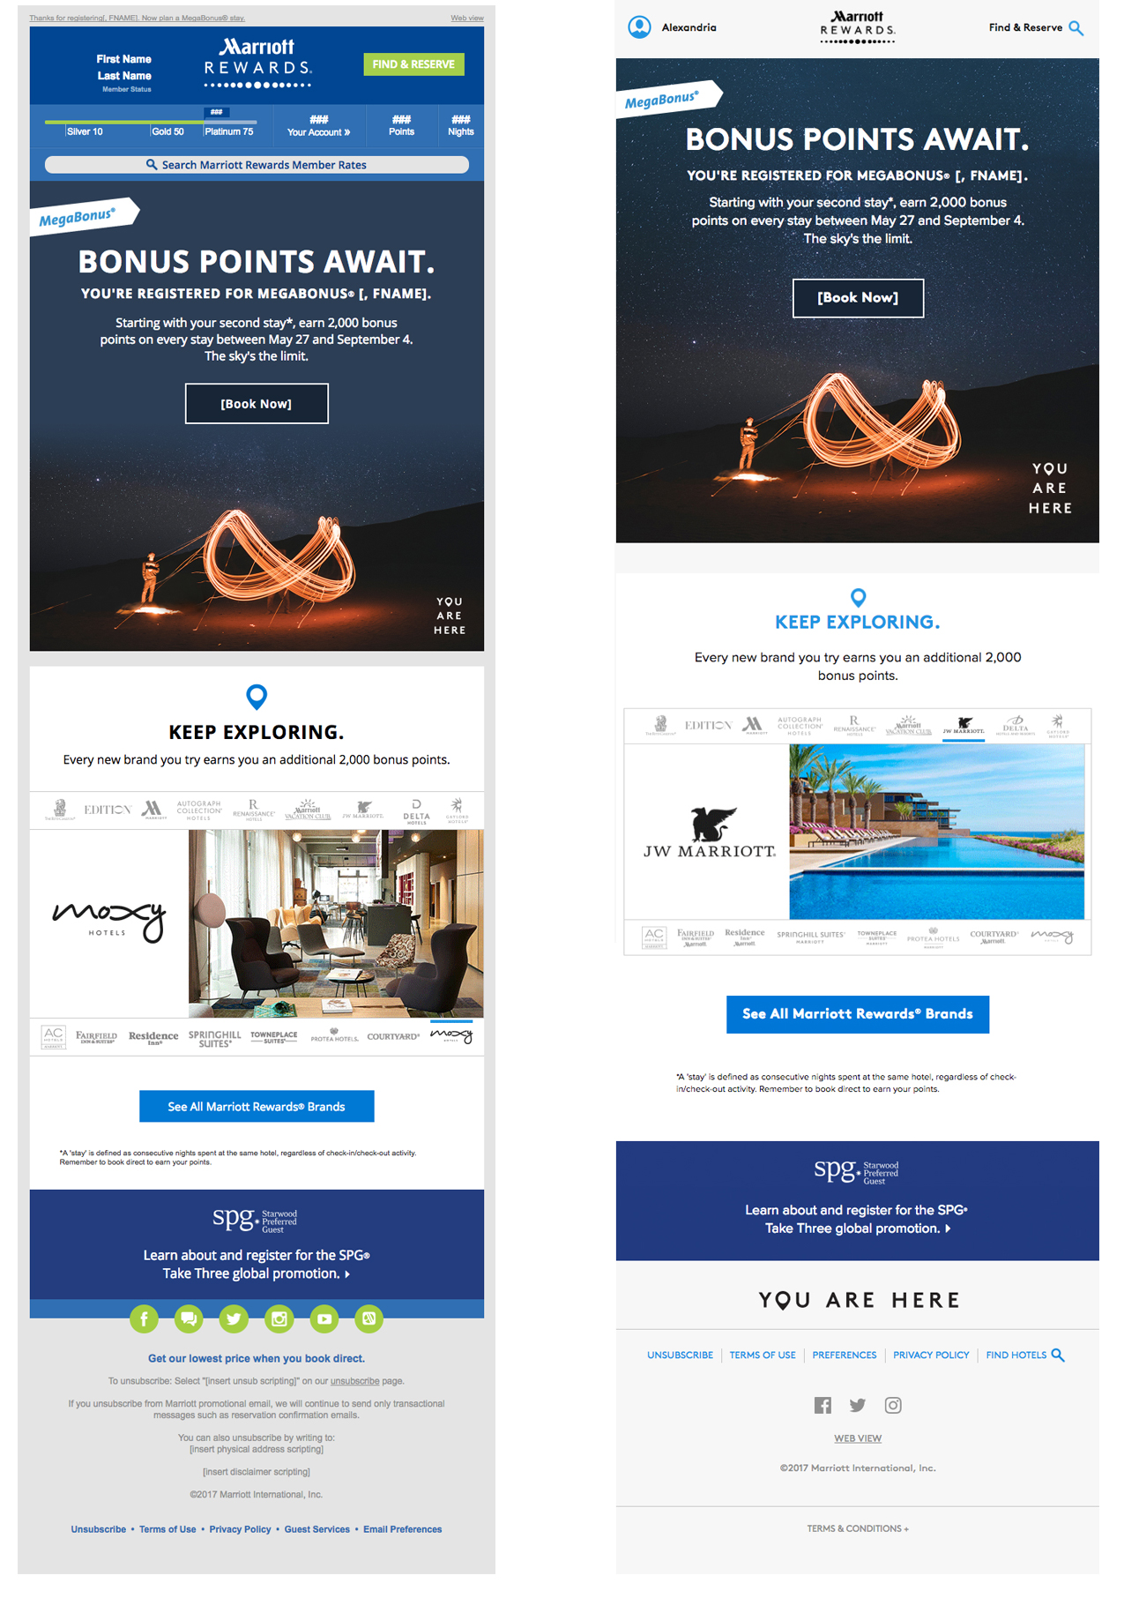
^ v14 version on left, 2.0 version on right

Hero

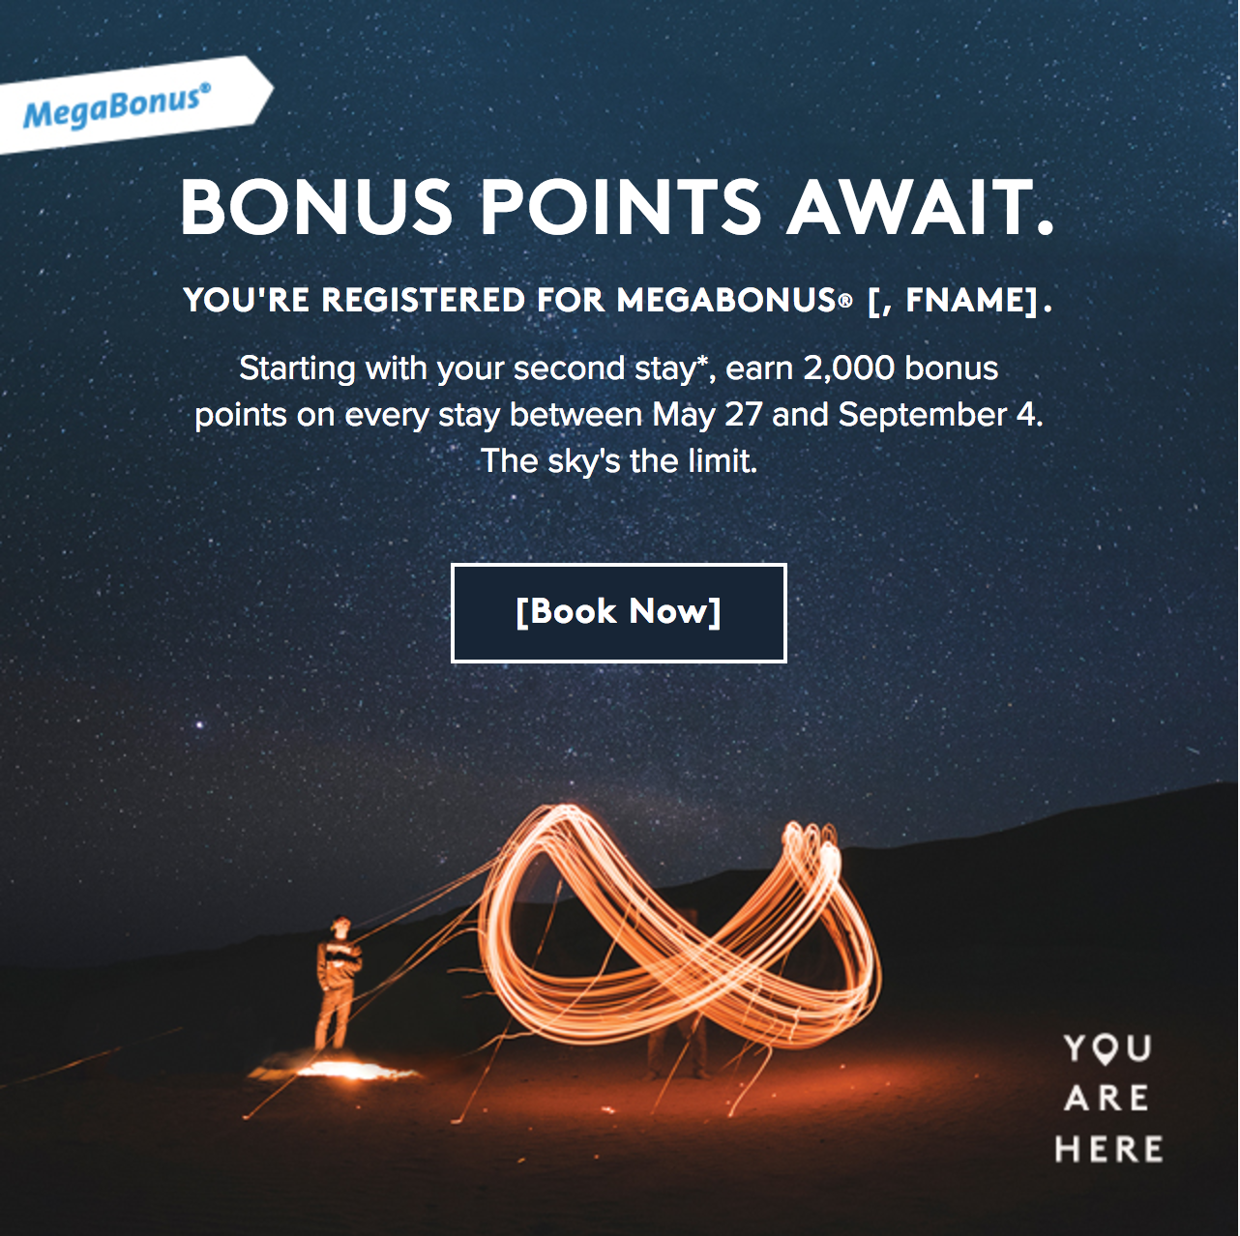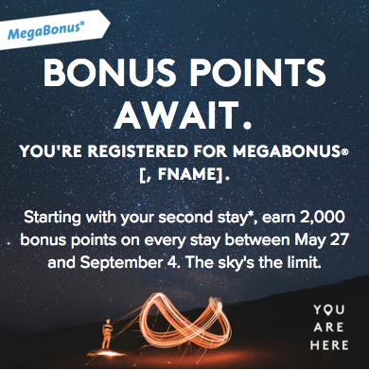
^ Desktop Image ^ Mobile Image

- The hero module (F2) is functioning as normal, with two images used for desktop and mobile views:
  - Desktop image: 2.0_Hero_640x640_v2.jpg
  - Mobile image: 2.0_Hero_414x414_v11.jpg
- The CTA has been adjusted to match the look of the style guide:
  - class="hoverDarkBlueCTA"
  - background:#172536;
  - border: 2px solid #ffffff;
- We are testing (3) hero CTAs against each other:
  - Book Now
  - Plan a Stay
  - Find a Hotel

Secondary Section



- This section is a patchwork of the following modules:
  - H2: Section Headline 2
  - T3: Tertiary 3 - Bulleted list with intro
  - F5: Feature 5 - No background image, copy centered
  - F6: Feature 6 - Copy only
  - F5: Feature 5 - No background image, copy centered
    - Uses an image swap for mobile view

- The image is an animated .GIF that scales well for mobile view

- I added the class ”mobilePadding1a”

.mobilePadding1a {
padding: 20px 20px 0px 20px !important;
height: auto !important; }

Requested Code Fixes

Secondary Section:

Changes are for mobile view only

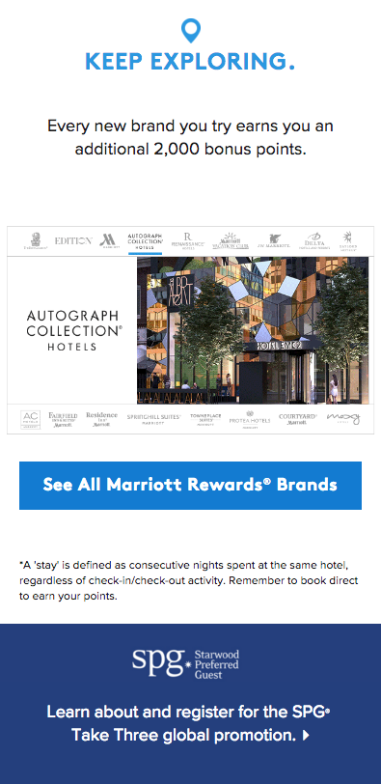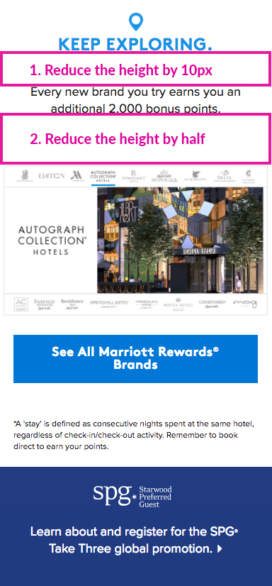

- Can you reduce the height between “Keep Exploring” and the body copy by 20px?
- Can you reduce the white negative space in between the body copy and animation by half?

