0439 Marriott More Emails (3)
WP Handoff Doc

Cover Page:
http://preview.4at5.net/email_domains/mar/0439/mar_0439.html

1 – Invitation:

2 – Earn:

3 – Redeem:

Design Notes:

• There are 3 emails in this series

• English only for all versions

Email 1 – Invitation

1. This email will be resent if not opened – so there are three sets of subsequent subject lines on the cover page.

2. This email will utilize Wylei to embed the hero video and to create a backup .GIF. Lacek needs to provide a video link (at this time we do not have it). A static fallback image will be provided by YM (we need video assets to make this).

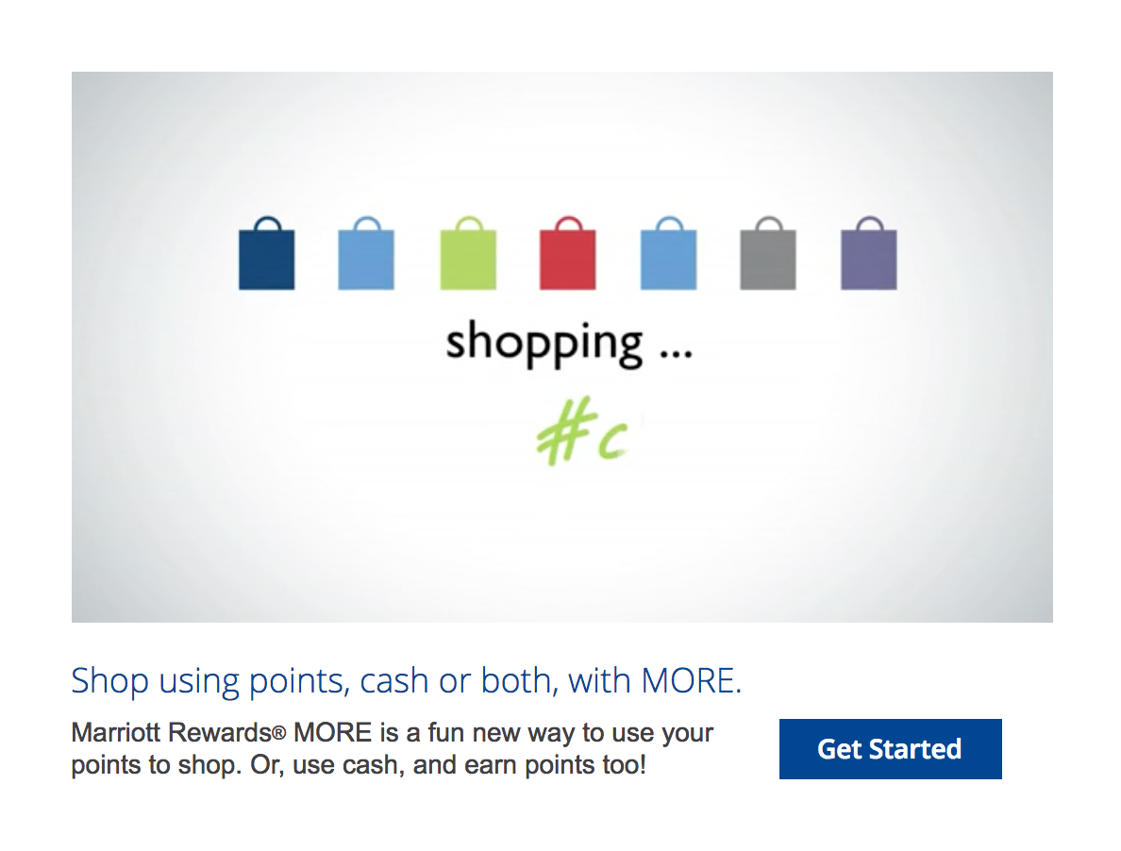

3. In the secondary module P14A “Earn points by using cash.” I manipulated the mobile stacking by changing this:

class="stack full-width-content"

to this:

class="mainCol"

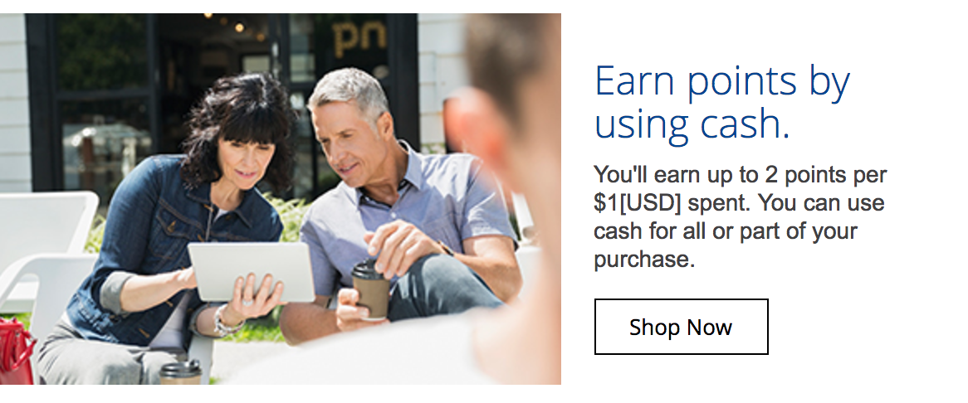

4. Also added the class “hide” to the gray dashed spacers to make them disappear in mobile.

Email 2 – Earn

• Only 1 send of this email

• In the secondary module P14A “Flexible spending. Easy earning.” I manipulated the mobile stacking by changing this:

class="stack full-width-content"

to this:

class="mainCol"



• Also added the class “hide” to the gray dashed spacers to make them disappear in mobile.

• The final credit card module has two versions/segments, only one will be sent out depending on the audience

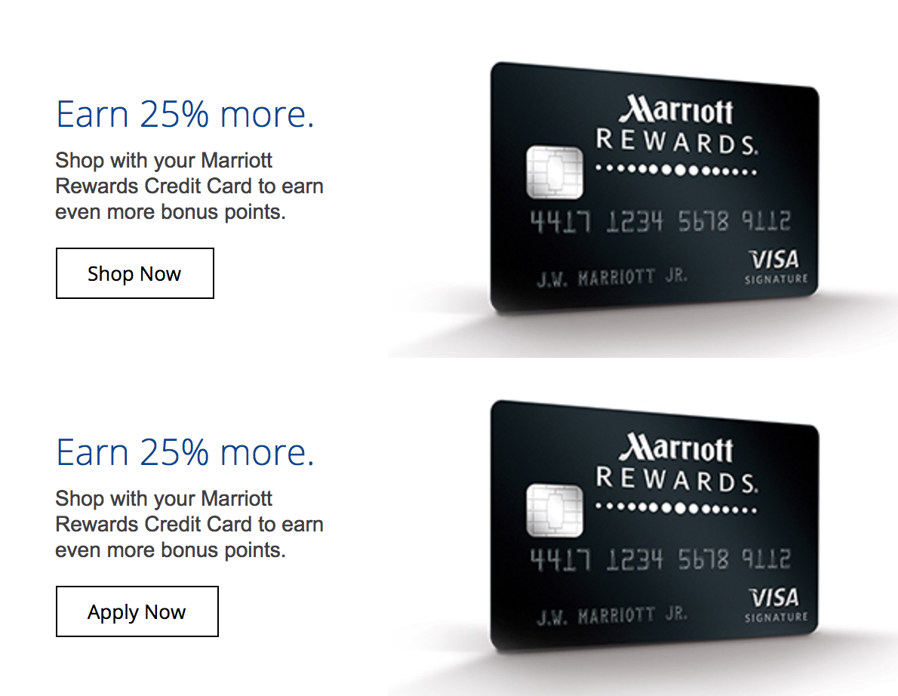

Email 3 – Redeem

• Only 1 send of this email

• In the secondary module P14A “More shopping flexibility.” I manipulated the mobile stacking by changing this:

class="stack full-width-content"

to this:

class="mainCol"

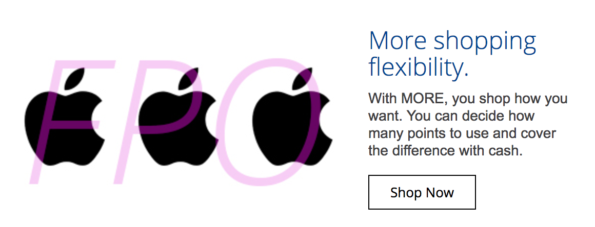

^Final module where stacking was revised. The image and copy will be revised by the design team before this goes to WP.

